**Investigating forest-dependent salamander species in disturbed landscapes in the western Oregon Cascades**

**Abstract**: Forests in the Pacific Northwest are seeing a drastic change in disturbance regimes as climate-induced wildfires increase in severity and frequency and overlap regulated disturbance like timberland. Salamanders are important bioindicators of forest ecosystem health, making it critical to understand their habitat requirements in landscapes that are impacted by novel disturbance regimes. We used principal coordinates analysis (PCoA), classification tree modeling, and random forest analysis to identify environmental drivers of salamander occupancy. The PCoA characterized environmental gradients among sites, with Axis 1 reflecting elevation and canopy cover, which distinguished harvested from unharvested sites, and Axis 2 capturing structural complexity, including downed wood and logs. These patterns suggest that unharvested sites retain critical habitat features such as dense canopy cover and abundant woody debris, while harvested sites exhibit reduced habitat complexity.

The classification tree identified decision thresholds for salamander occupancy, emphasizing the importance of mid-elevation forests (1173–2846 feet) with dense canopy cover (>1.8) and high soil moisture (>12). Seasonal timing (Julian date) influenced detection probability, but stable microclimatic conditions (e.g., canopy cover and soil moisture) were more important predictors. The random forest model confirmed these results, highlighting soil moisture, log abundance, and structural complexity as key contributors to habitat suitability. Together, these analyses suggest that salamanders occupy a distinct environmental niche characterized by stable, moist microhabitats with abundant woody debris.

These findings underscore the resilience of salamanders to natural disturbances such as wildfire but reveal their sensitivity to anthropogenic impacts, particularly timber harvest. Conservation efforts should prioritize preserving mid-elevation forests with dense canopy cover and downed wood, as well as implementing post-harvest practices that retain coarse woody debris and minimize soil compaction. Future research will expand on these insights by comparing responses of salamanders with differing life histories and further investigating statistical relationships between key environmental variables and salamander occupancy.

**Introduction**: Ecosystem structure and function in forests of the Pacific Northwest (PNW) are strongly influenced by disturbance history, including wildfire and resource management1,2. Clearcut logging, a major component of intensive forest management, has been a significant driver of successional pathways in the PNW for a century. Since the early 1900s, the conversion of old growth conifer dominated stands to logging plantations has altered canopy structure, downed wood distribution and density, and early seral pathways1,3. This legacy of timber harvest has altered forest macrohabitat and microhabitat conditions by reducing the proportion of large-diameter trees, thereby reducing downed wood recruitment, altering vegetation structure and composition, and impacting soil conditions4–6.

This disturbance has also drastically simplified forest structure across the PNW, thereby altering the natural fire regime in this region, which has played a critical role in the dynamics of Pacific Northwest (PNW) forests. In the Oregon Cascades region, fire events have historically been driven by infrequent east-driven wind patterns and lightning storms occurring late in the summer, after a dry summer climate presents suitable burning conditions 7–9. The infrequency of these triggers has historically resulted in long fire return intervals (>150 years). Due to topographic diversity at middle elevations, moderate frequency (35-150 years) mixed-severity fire regimes are also interspersed7–9.This patchwork of fire types creates heterogeneity within age classes, species composition, and successional pathways across the landscape8,9.

The disturbance patterns of the Western Cascades of Oregon are shifting drastically in recent decades as climate change alters fire patterns, causing overlap in natural and anthropogenic disturbances. Timberland accounts for 35% of the state’s forest land, creating the opportunity for frequent overlap in timber harvest and wildfire as fires become more frequent2,10,11. These impacts in conjunction with climate shifts are contributing to increased severity and frequency of fires in the 21st century, including the 2020 wildfires in the western cascades12. The 2020 wildfire event produced severities that were unprecedented in the contemporary record for Oregon, subsequently burning over 11% of the Oregon cascades, more than 4000 homes, displacing 40,000 people, and accumulating $1.15B USD in damage10. Climate projections suggest the PNW will continue to see longer fire seasons in coming years, owing to longer and more extreme dry seasons which will increase fuel aridity and fire weather, predicting further disturbance of natural patterns10.

The temperate rainforests of the western Oregon cascades are a hotspot for amphibian diversity, many of which are endemic to the PNW13. Global amphibian declines are occurring at higher rates than any other vertebrate taxa, making amphibian conservation high priority14. Amphibians are particularly susceptible to habitat change due to a reliance on cool, moist conditions, thus are commonly coined as “indicator species” and used to make inferences about ecosystem health and forest disturbance outcomes15. Terrestrial salamanders in the family Plethidontidae, the lungless salamanders, rely on cutaneous respiration, requiring environments with high moisture and consistent temperatures to prevent dehydration5. Plethodontids are strongly tied to downed wood for foraging, reproduction, and temperature stress refugia, and have low dispersal rates, making them particularly susceptible to potential forest floor impacts5. Due to this sensitivity to micro and macro habitat changes, studies of terrestrial woodland salamanders are important for investigating forest change.

This project is focused on two terrestrial salamanders native to the western Oregon Cascade Mountains: the Oregon Slender salamander (Batrachoseps wrighti, BAWR) and Ensatina salamander (Ensatina eschscholtzii, ENES). The Oregon slender salamander is known as a sensitive species with a small home range, approximated dispersal distance of 1.7m, and specific habitat requirements 16. They spend much of their lifetime underground, emerging only when ideal climatic conditions arise. The range of BAWR overlaps both private timberlands and 2020 wildfire zones (Figure 1), and due to its utility as an indicator species and proximity to overlapping disturbances of interest, this taxon has become an ideal candidate for studying climate resilience in this region. In contrast, the Ensatina salamander is considered a generalist, is widespread throughout the western US, and is known to occupy a broad gradient of microhabitats5,17. These two species provide an interesting contrast in life histories and potential response to multiple disturbance events, though both species maintain a strong association with downed wood and mesic environments owing to their moisture-dependence.

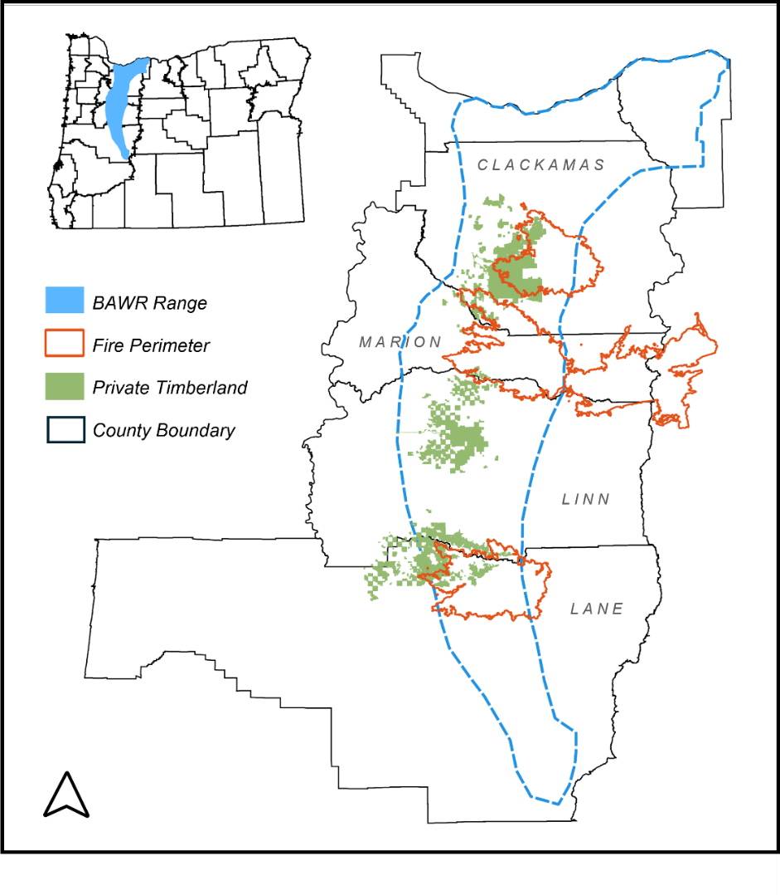Throughout this project we aim to understand (1) how wildfire and timber harvest impact forest floor habitat, and (2) which habitat variables are the primary drivers of salamander occupancy. While knowledge on the relationship between timber harvest and wildfire is limited in the literature, evidence suggests that the combination of both disturbances can alter many components of forest floor habitat and microclimate, including carbon storage, ambient temperatures, soil nutrient composition, soil moisture, and within-wood temperatures4. All these things can impact refugia potential for an animal requiring high levels of moisture and stable temperatures. Past research has elucidated relationships between salamanders, harvest, and downed wood, though significant data gaps remain on the effects of wildfire on these species, and how downed wood size, condition, and distribution might mitigate these effects.

Figure 2. The range of Oregon Slender Salamander in OR, USA.

**Methods**:

*Study Area*: We surveyed 127 sites in the Western Cascade Range, OR over two field seasons, from 2023-2024. Forest stands are owned and/or managed by Weyerhaeuser Co., Port Blakely Tree Farms LP, Bureau of Land Management, and Oregon Department of Forestry. The following parameters were used for site selection: all stands were greater than five hectares in size, over 45 years in age, lower than 3000 feet elevation, and within the range of both BAWR and ENES. For burned sites, we included stands within high severity burns only, using existing burn severity metrics determined by remote sensing and ground survey information. A single forest stand boundary could include multiple sites, with a required minimum of 100 m between locations to be considered separate sites. This metric is based on the estimated maximum dispersal distance of both target species, to ensure the ability to consider each site a separate unit in the occupancy study. Each site was categorized into one of five categories based on recent disturbance history (Table 1).

Table 1. Breakdown of treatment categories with the number of plots surveyed over two seasons

|  |  |  |  |
| --- | --- | --- | --- |
| Code | Treatment | Description | Survey Total |
| HB | Harvested/Burned | Sites that were harvested in the BACI study (post-2015) and then burned in the 2020 fires | 25 sites |
| UU | Unharvested/Unburned | Control sites; Sites that have not been harvested in at least 50 years, and did not burn | 25 sites |
| BS | Burned/Salvaged | Sites that were not harvested 50 years pre-fire, burned, and were subsequently salvage logged | 24 sites |
| HU | Harvested/Unburned | Sites that were harvested in the original study (post-2015) and did not burn | 27 sites |
| BU | Burned/Unharvested | Sites that have not been harvested in at least 50 years, burned in 2020, and were not harvested since | 26 sites |

*Data Collection*: We performed surveys for occupancy and abundance of BAWR and ENES at each of 127 sites. Within each site, we sampled seven 81m^2 (9x9m) plots, which was determined based on salamander home range size and systematic searching ability. A random start point was chosen as the centroid of the first plot, and 6 additional plots were established in a circle around the centroid with 35m between each plot (Figure 2). Each plot was sampled for three ten-minute intervals over the course of a single day, between 0800 and 1600 from March – June, 2023—2024, with a new observer for each subsequent survey. Surveys included lifting all surface objects in the plot, including logs, rocks, leaf litter, moss mats, and other debris, and returning them to their original positions. Searching for BAWR required disassembling rotting downed wood, as the animals do not often exit their refugia, and required best effort in returning debris as close to its original position as possible to avoid negatively impacting the habitat quality within a plot.

Site level data collection included ambient temperature, relative humidity, elevation, and treatment verification. Plot level data included soil moisture using handheld volumetric soil moisture probes at three points across the plot, downed wood quantity, size, decay class, and pyrogenic carbon class, and visual estimates of canopy cover, downed wood cover, fine woody debris cover, and vegetation cover. Each salamander found was recorded by species. If the animal was a target species, crews recorded age class based on snout-vent length measurement, the cover object, and substrate where detected.

*Data Analysis*: Salamander and environmental data were analyzed using a combination of ordination techniques and decision tree methods to address our two study questions. A Principal Coordinates Analysis (PCoA) was used to characterize sites and explore the influence of disturbance on habitat variables. Classification tree and random forest methods were used to elucidate the predictor variables for salamander occupancy. All analyses were performed in R using RStudio Version 2024.09.1+394.

To summarize and visualize variation in habitat variables across disturbances, a Principal Coordinates Analysis was conducted using the cmdscale() function in R. PCoA is a multivariate technique that reduces complex data to a set of principal coordinates while preserving the distances between samples in a lower-dimensional space. A Euclidean distance matrix was calculated from z-standardized environmental variables, which were then used as input for the analysis. Five axes were retained (k=5), capturing the primary gradients of variation in the dataset.

To identify key environmental predictors of BAWR species occupancy, a classification tree analysis was performed using the rpart() function in R, with BAWR presence/absence as the binary response variable and continuous environmental variables as predictors. The initial tree model was grown with a minimum split size of two and cross-validation with five folds. To prevent overfitting, the tree was pruned to an optimal CP value of 0.044, selected based on cross-validation results. The pruned tree was subsequently visualized to identify the most influential predictors of BAWR presence.

Following the classification tree analysis, a random forest model was implemented to validate the results and identify environmental variables most strongly associated with BAWR presence. The random forest analysis was conducted using the randomForest() function in R, with the binary occupancy response treated as a factor and continuous environmental variables as predictors. The model was configured to grow 5000 trees and evaluate five predictors at each split. The random forest approach provided a robust comparison to the classification tree results and insights into the relative importance of predictors in determining BAWR occupancy.

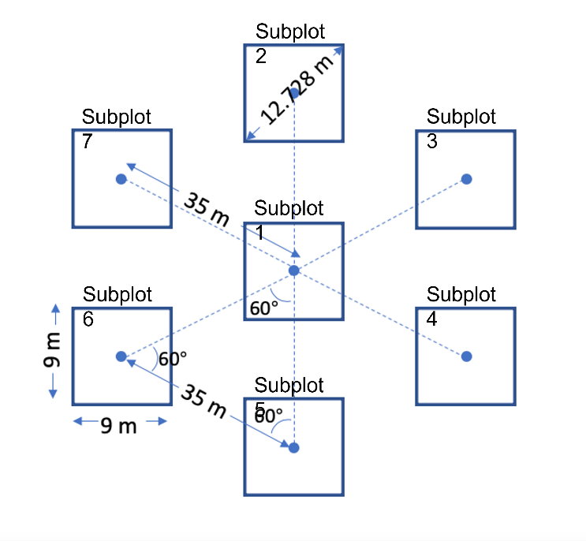

*Top left:* **Figure 2, Plot schematic** used to collect salamander and habitat data.

*Top right:* **Figure 3, Principal Coordinates Analysis** biplot using all sites from 2023 and 2024 surveys. Treatment categories are classified by color, and primary environmental variables are noted on vectors.

*Bottom:* **Figure 4, Classification Tree.** Data represents only BAWR occupancy. Primary nodes include elevation, canopy cover, and soil moisture.

**Results**: The PCoA results showed canopy cover as a primary driver of differences in site classification, with soil moisture and some downed wood metrics influencing these classifications as well. By analyzing the descriptors and calculating their loadings, we determined the composition of major axes in the PCoA. The first three axes of the PCoA explain 63% of the variation in the data, with axis 1 explaining 38.31% and axis 2 explaining 24.71%. Axis 1 is strongly influenced by positive canopy cover, and moderately influced by negative stump presence and positive soil moisture. Axis 2 is moderately influenced by downed wood percent cover and logs in the negative direction. These gradients are visualized in the biplot below (Figure 3). In the plot, logs, canopy cover (canopy_cov), downed wood cover (dwd_cov), and stumps are the most important drivers. The direction and length of their arrows visually indicate their contribution to the gradients in environmental conditions. Sites with high canopy cover are situated on the right side of the plot, including sites within unharvested treatment categories. Sites with higher stump presences are situated on the left, including mostly harvested treatment categories. Sites in the lower left quadrant are more likely to have higher downed wood cover.

The classification tree identifies elevation, canopy cover, and soil moisture as key variables that influence the presence or absence of the target species, BAWR. Elevation is the most important variable at the root and at a secondary split, with most of the salamander presence data falling between 2846 and 1173 feet. Two terminal nodes account for the largest percentage of the data. The highest node accounts for 39% of the data, predicting “Present” with a probability of 0.71, if the following conditions are met: elevation is less than 2846’ and greater than 1173’, canopy cover is less than 1.8, the date is after April 5, and soil moisture is less than 31 but greater than 12. The second highest node predicts “Present” with a probability of 0.92 covering 19% of the data if the following conditions are met: elevation is between 2486’ and 1173’ and canopy cover is greater than 1.8. At mid-elevation sites, salamanders are more likely to be present when canopy cover is high. At low elevations, soil moisture becomes more important, with occupancy increasing for higher soil moisture. We also see Julian date is important at low elevations, with early season conditions (before April 5) having lower occupancy. Mid elevations with high soil moisture result in 100% predicted occupancy, while high elevations result in 100% predicted absence.

The random forest model shows Julian date, elevation, and canopy cover as primary indicators of salamander occupancy. This can be visualized in figure 4. The x-axis shows mean decrease in accuracy, which indicates how much accuracy is lost when a variable is removed from the model. Larger values suggest that the variable is more important for predicting salamander occupancy. Moderately important variables include soil moisture, log abundance, and log length class. The model output indicates that the model misclassified approximately 29.13% of observations during cross-validation using the OOB samples. The confusion matrix shows that it struggles to correctly classify "Absent" cases. It misclassifies 29 out of 50 "Absent" observations (58% error).

Figure 4, Variable Importance from Random Forest Model

**Discussion**: The PCoA, classification tree, and random forest model worked together to characterize the landscape and explore habitat characteristics in the context of salamander occupancy and suitable microhabitat conditions. All three analyses agree on a suite of environmental characteristics that are important both for characterizing the differences among sites and for predicting salamander occupancy. These include canopy cover, elevation, soil moisture, Julian date, and to a lesser extent, downed wood cover and log size.

The PCoA provided an overview of environmental gradients within our sites and interpreted site-level variation. Axis 1 primarily captured elevation and canopy cover, which aligns with their importance in both the classification tree and random forest models. Canopy cover is a direct proxy for harvest impact, and this axis has split sites into two halves with harvested sites found on the left side of the plot and unharvested on the right.

Axis 2 captures variations in structural complexity of the forest floor (downed wood and logs), where high wood-scoring sites are found in the bottom half of the plot. The presence of downed wood on axis 2 shows that it is found in both harvested and unharvested sites in some capacity. This may mitigate some harvest impacts on salamander refuge capacity. Downed wood and structural complexity of the forest floor not only offer refuge from predators but also maintain critical microhabitats by buffering temperature extremes and retaining moisture, essential for terrestrial amphibians.

This ordination characterized harvested sites as having different habitat conditions than unharvested sites, which seems to be minimally influenced by site burn status. This gives insight into how two disturbances behave on the landscape together and suggests that wildfire may create less disturbance in the variables that we measured. Given that our goal was to measure variables that could be impactful to the persistence of suitable salamander habitat, this could be an indication that the impacts of wildfire are less harmful to salamander habitat than timber harvest.

The classification tree further distilled these multivariate relationships into actionable thresholds, and showed that elevation, canopy cover, soil moisture, and Julian date are strong predictors of salamander presence. Elevation is the primary driver of occupancy in the classification tree model, with high occupancy at elevations between 1173 and 2846 feet and unsuitable conditions at very high elevations. Mid-elevation sites with higher canopy cover and soil moisture offer the most favorable habitats. We know that temperature gradients are important factors influencing salamander distribution, and the elevational gradient is likely an example of this gradient.

Seasonal timing and specific moisture thresholds influence occupancy at finer scales in the classification tree, particularly in lower elevation habitats. While Julian date emerged as an important predictor in the classification tree, it is more reflective of detection probability than true occupancy. Salamanders are known to be active only under specific environmental conditions, often tied to seasonal temperature and rainfall patterns. These findings highlight the importance of accounting for detection biases in future models. For those reasons we won’t consider Julian date to be of particular importance for occupancy, though this analysis confirms its importance for detection probability.

The random forest verified these actionable thresholds from the classification tree, and added robustness to these findings by identifying soil moisture and log abundance as additional key contributors to habitat suitability. The gradient along Axis 2 of the PCoA, capturing downed wood abundance, also validates its moderate importance in the random forest model. These findings suggest that salamanders occupy a distinct environmental niche characterized by stable microclimatic conditions and emphasize the importance of structural habitat features in predicting salamander presence. The finding that wildfire creates less disturbance in canopy cover and soil moisture compared to harvest treatments also suggests that salamanders may be more resilient to natural disturbances than anthropogenic ones.

Together, these analyses suggest that mid-elevation forests with dense canopy cover, high soil moisture, and adequate woody debris represent priority habitats for conservation efforts targeting salamander populations. To maintain salamander populations in managed landscapes, efforts should focus on preserving mid-elevation habitats with dense canopy cover and abundant downed wood. Additionally, post-harvest treatments should aim to retain coarse woody debris and minimize soil compaction to enhance moisture retention. These practices could help mimic conditions in unharvested forests, providing critical microhabitats for salamanders.

These results underscore the importance of maintaining stable microclimatic conditions in the face of increasing anthropogenic and climate-driven disturbances. Salamanders are widely regarded as bioindicators of forest health, and their sensitivity to habitat changes underscores the need for sustainable management practices. In the face of increasing anthropogenic and climate-driven disturbances, protecting mid-elevation forests with dense canopy cover and high structural complexity will be critical to maintaining biodiversity and ecosystem function in the Pacific Northwest.

While these analyses identified key habitat drivers, they are exploratory and may not account for other important variables such as time since harvest and rainfall. These analyses underscore the need for further research on key habitat characteristics and their statistical relationships to salamander occupancy. Future research should incorporate these factors and use regression models to validate and quantify the relationships between environmental variables and salamander occupancy for both species. This will allow us to compare responses from species with differing life history strategies on this disturbed landscape. We hope to eventually provide information that will educate management decisions and help managers understand the combined impacts of these disturbances on our changing forests in the pacific northwest.